React

It is a Javascript library used to develop single page applications, it follows component based approach to develop the UI.

Single page application

It is an application where you can see everything in one page, if user clicks on a button or a link or any element only part of the page will be loaded instead of loading the entire page.

ex: Facebook, Git, Twitter, Git hub and so on.

Component: These are reusable UI’s which you can see in the page and they can be nested in other components, you can develop and maintain the components independently and fit the components wherever you need.

Note: React.js is used only to develop User Interface.

Advantages of React.js

1. It is easy to learn and understand
2. It uses components which are easy to maintain and test
3. It can be used to develop UI’s for many platforms like Mobile, Web and DVR.
4. It is a library and encourages you to add any javascript libraries you wish ex: axios to call back end, bootstrap js to style or materials to style and so on.
5. It provides javascript libraries to perform unit testing.

Pre-requisites

1. HTML
2. CSS
3. Javascript
4. New Features of Javascript (ECMAScript or ES6 and latest)
5. JSX (Javascript XML, extended version of Javascript).

Softwares required

1. Visual Studio Code editor
2. Node.js (Javascript Runtime Environment)
3. Browser

React.js is developed using JSX, which is an extended form of Javascript.

Why JSX

JSX is easy to write compare to Javascript when comes to developing UI’s i.e., writing HTML code is easier in JSX compare to Javascript

Brief Overview of Contents

* React.js
* JSX
* ES6+ Features
* VDOM
* Components
* Controlled Components
* Props & States
* HOC
* Render Props
* Advanced concepts
* Router
* Axios
* Redux
* Testing
* Materials
* Javascript or Node.js libraries i.e., Express

Understanding the new features of Javascript i.e., ES6+

ES6 onwards the javascript syntax has slightly changed.

ECMAScript or ES

* It is standard that will have set of rules & regulations which is implemented by Javascript, Node.js, Browser
* It has different versions like ES6, ES7, ES8 and so on
* In each versions new changes are added.

What are the main changes introduced in ES6 or later

* New keywords in javascript like let, const, class, constructor, super
* Template String literals
* Arrow functions
* Static members
* New functions in Object like entries & value
* New functions in String like padStart & padEnd
* Generators
* Object Destructuring
* Rest & Spread operators
* Default arguments
* Optional Chain
* Trailing commas
* Exponential Operator
* includes in Arrays

Understanding let & const keyword

let & const keywords are used to create block scoped variables, because earlier javascript had var keyword to create variables which would become global variable when you create.

varDemo.js

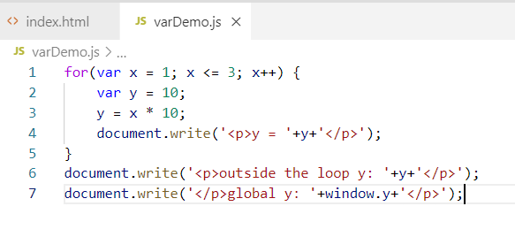

index.html

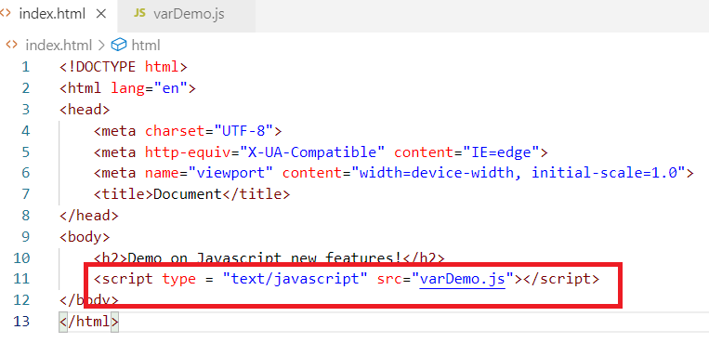

Output:

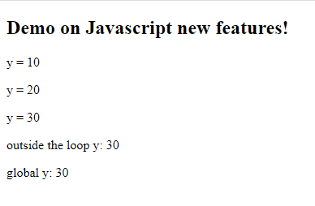

Here the problem is you can access the variable which is declared inside the loop i.e., outside the loop also they are accessible, which is not secure, hence we have let & const to declare variables.

let & const variables wouldn’t be added to window object.

let is used to create block scoped variables & you can modify it within the scope, but you can’t access outside the scope

const is used to create constants, it is also block scoped variable, but you can’t modify it.

letDemo.js

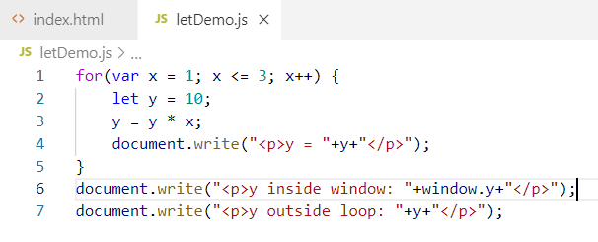

Output:

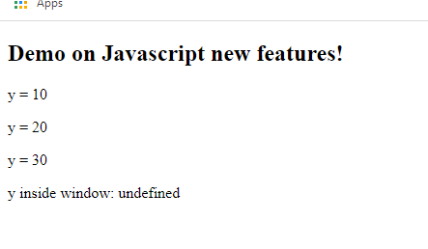

Since let keyword doesn’t add the variables inside the global object, the window.y gives undefined & also accessing the ‘y’ outside the scope gives error in the browser console.

constDemo.js

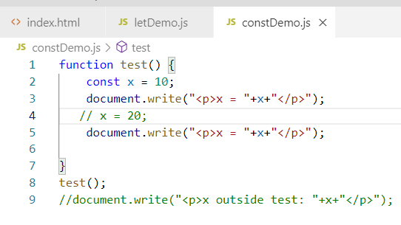

The above code gives error at the line no. 4.

But the object properties are not constants.

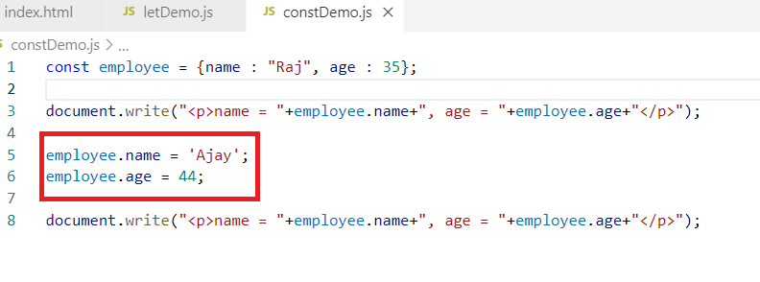

Output:

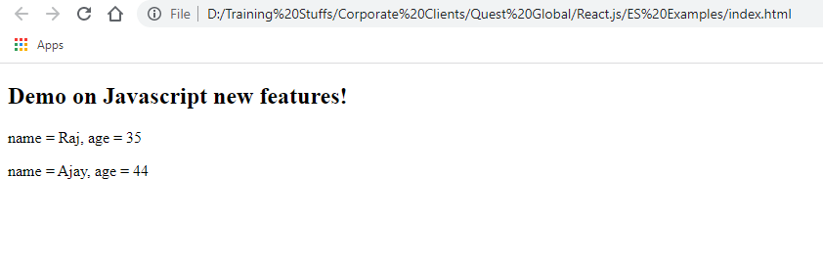

The above code lets you modify object properties though it is const, but to avoid modifying properties you need to freeze the object using Object.freeze.

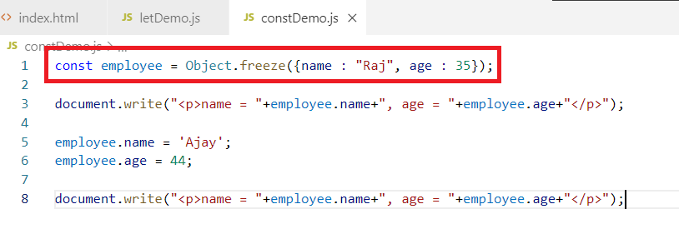

Output:

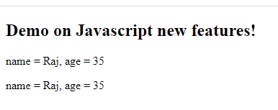

The above code makes the entire object freeze so that you can’t modify this was there even before ES6.

Differences in var and let

|  |  |
| --- | --- |
| var | let |
| It is global | It is block scoped |
| by default variables without any keyword takes var | by default variables doesn’t take let |
| You can redeclare same variable | You can’t redeclare same variable |

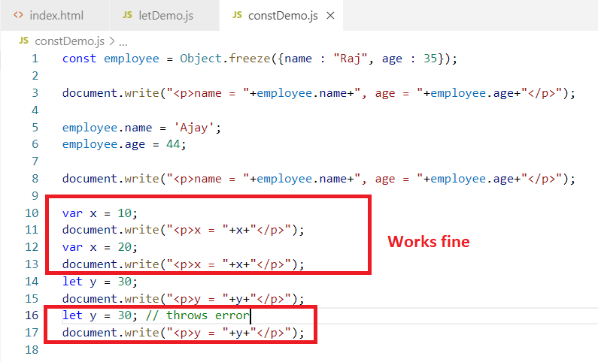

Arrow functions

These are used to simply writing callback functions with a simpler syntax that eliminates using function keyword, {} if it’s a single line statement, return keyword if it’s a single line statement.

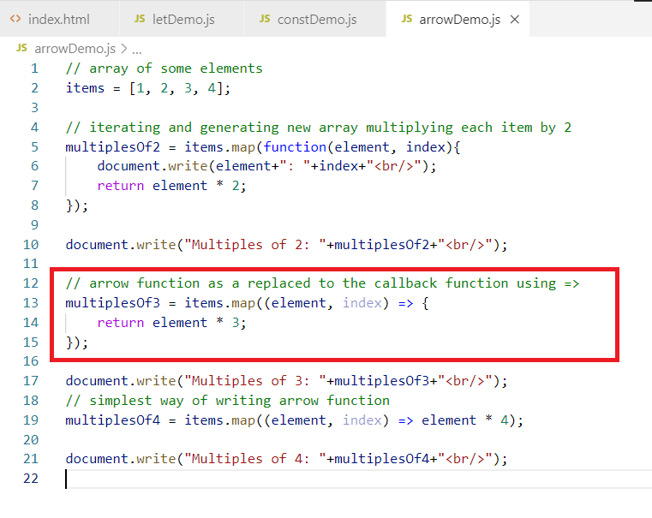

Note: If in case the callback has only one line statement then you can avoid writing {}.

Valid arrow functions

() => “Hello World”: This takes no arguments & returns string

(x, y) => x + y: This takes 2 arguments & returns addition of 2 arguments

(x, y) => return (x + y): Not valid, use return inside { }

(x, y) => { x + y; }: This is also not valid, you must return the expression or create some valid statement, since in javascript a function need not to return always.

Day 2 agenda

* class, constructor, inheritance
* default parameters
* rest & spread operator
* static members
* generators
* string template literals
* object destructuring
* exponential operator
* trailing commas
* optional chain
* Object entries & values
* Arrays include

class in Javascript

Before ES6 adding functions to the object was done using prototype and also object constructor were created using function keyword, but from ES6 onwards you can add functions in an object and constructors through class keyword.

Before ES6

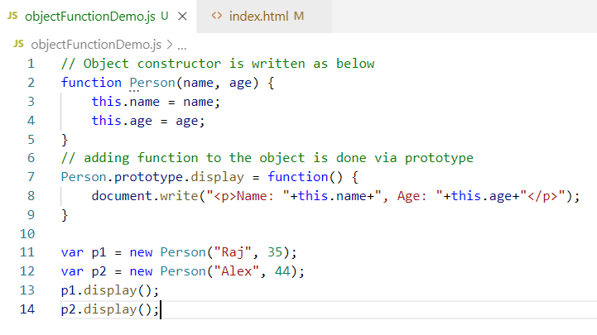

Here the prototype lets you add new functionalities to the existing object and also you use function keyword to create the constructor which initializes object properties, you must use this keyword inorder to access object properties inside its function.

Output:

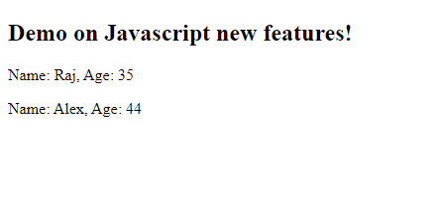

But from ES6 onwards you have a simpler syntax through class keyword you can create constructors & functions, so that you can encapsulate the functions that are part of the object

You need to use class & constructor keyword

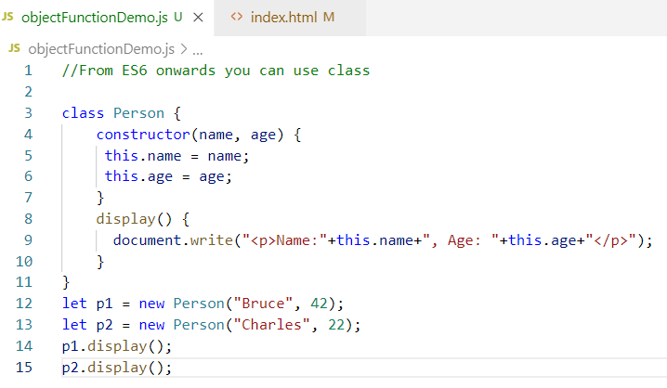

Output:

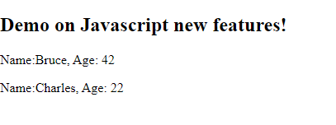

Inheritance in Javascript

From ES6 onwards you have new keywords to achieve inheritance that is extends keyword and also you can call super class constructor using super keyword.

But before ES6 you need to use prototype to achieve inheritance

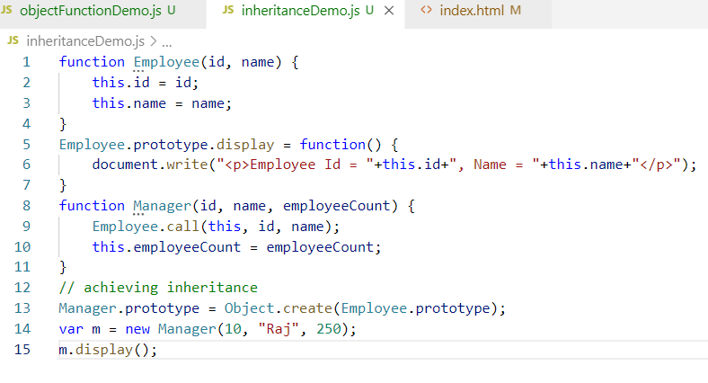

Earlier you need to use prototype to achieve inheritance

Output:

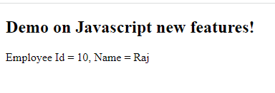

From ES6 onwards you have new keywords like extends & super using which you can achieve inheritance.

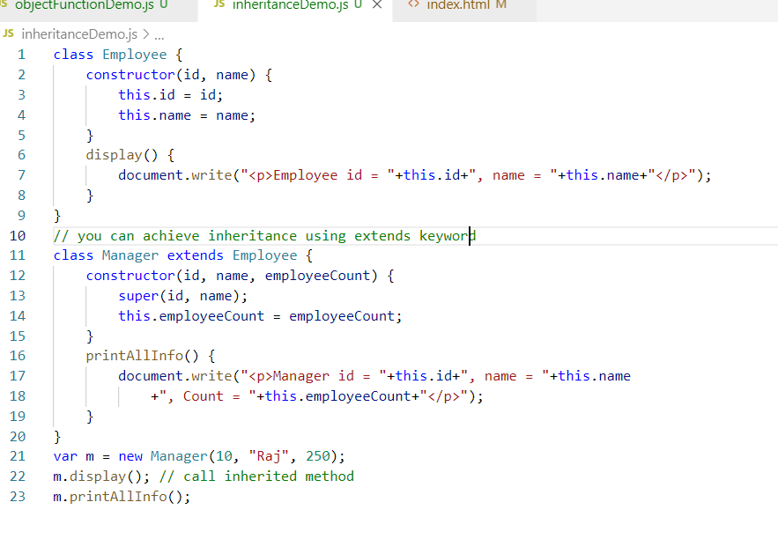

In ES6 the syntax to inherit and call the super class constructor is much simplified

Output:

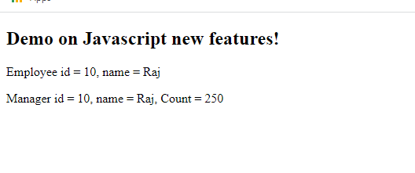

Default parameters to the function

Since in Javascript you can skip passing right number of arguments when function is taking some parameters you need to use some default values when the right number of arguments are not supplied to the function, in that case you need to check for the type and assign default value.

Before ES6 developers used to check for undefined to assign the default value through some conditional constructs which is shown as below.

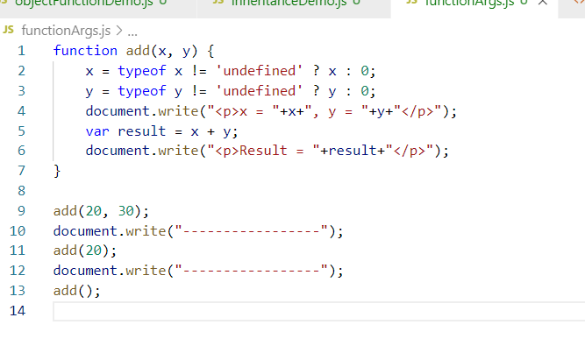

In the above code we are checking x & y has value or not, when x & y are undefined they get 0 by default else x & y considers value you supply to the add.

Output:

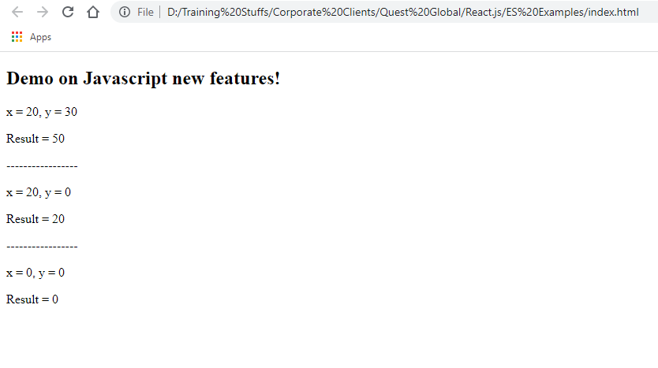

Note: If you don’t write the condition you will get x & y undefined & result will be NaN

The problem with the old approach is you need to check each parameter to assign the default value, if the number parameters are more you write more number of type checking code

Hence in ES6 they introduced default parameter function where you can assign default value to the parameter at the time defining the function

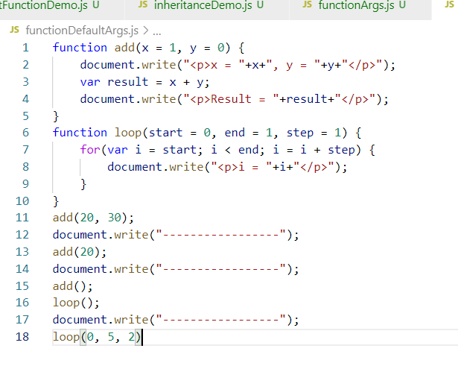

Output:

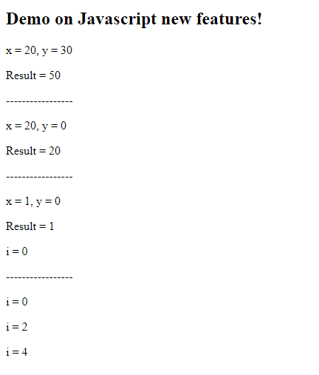

Template literals for Strings

It allows you to create strings & concatenate strings without + operator so that you don’t need to break the strings when you want to show some dynamic data, before ES6 you need to break the string to show the dynamic data and when your javascript is showing the data using HTML it is very difficult to write HTML as you need to break the strings to show the dynamic data as below:

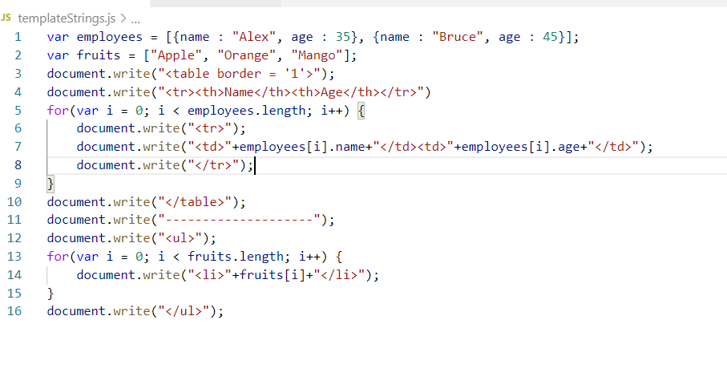

Output:

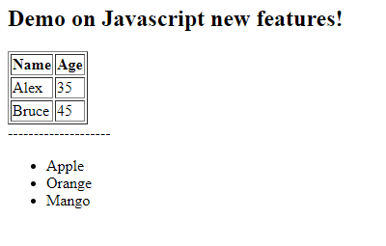

From ES6 onwards template string literals made easy to create strings with dynamic data without breaking it, it uses an expression with ${data} and string must be created using backtick `(below the ESC key)

Ex: `Hello ${name}` can be used instead of “Hello “+name

From ES6 onwards

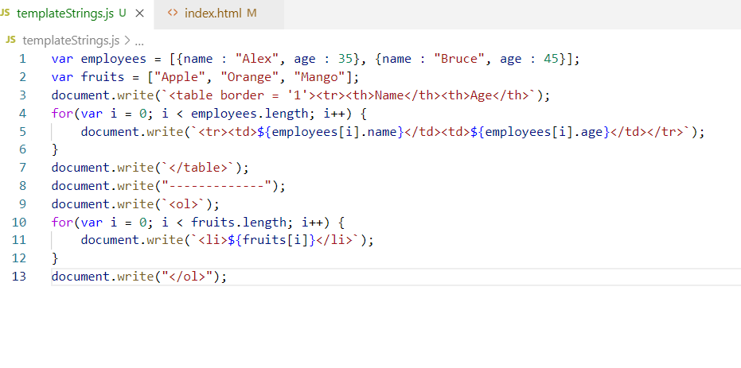

Output:

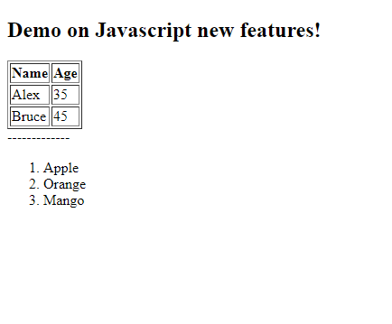

Another use of template string is you can concatenate multiple variables to prepare the webservice URL to call the back end service

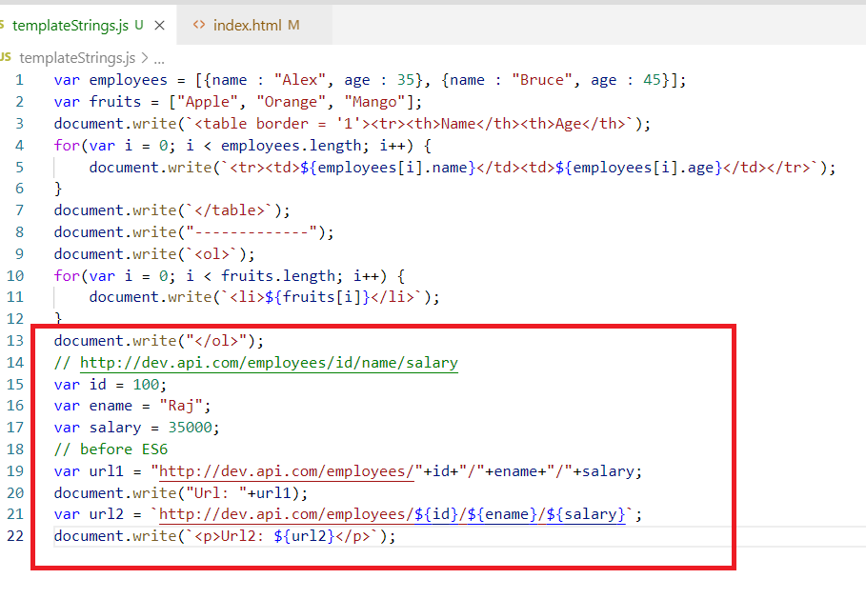

Output:

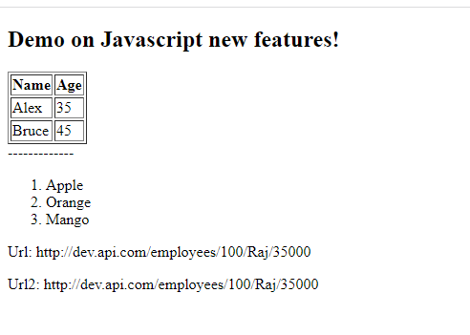

Array & Object Destructuring

It is one of the cool feature added in ES6 which allows you to unpack values from the arrays or object into distinct variables. you can extract data from arrays or object properties & assign them to the variables in a single statement

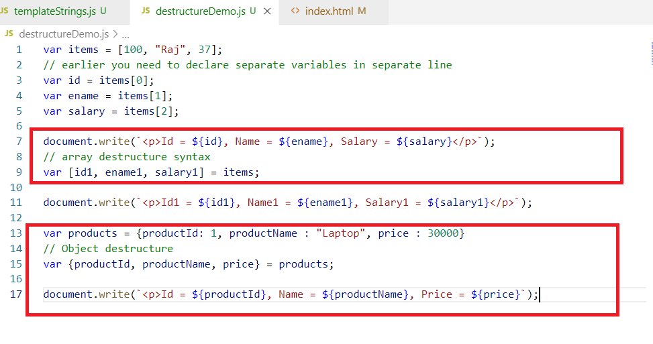

Output:

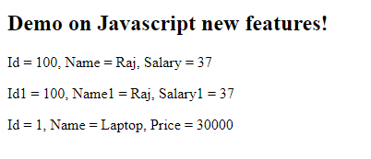

Rest & Spread operator

These are used to pass multiple inputs to the function parameters and not to loose any data

Rest: It is used in the function parameter which can accept 0 or more arguments

Ex:

function test(a, b) { } can accept maximum 2 arguments i.e., test(10, 20)

However if you pass test(10, 20, 30) then 30 will be lost because test accepts only two arguments, but in Rest operator you can avoid this data loss

i.e.,

test(a, b, …c){}

Here a & b are normal parameters but c is a rest parameter which accepts 0 or more arguments, but here in test you must pass atleast 2 arguments minimum and c is optional

you can call test by following ways

test(10, 20) : here a = 10, b = 10 & c = []

test(10, 20, 30): here a = 10, b = 20 & c = 30

test(10, 20, 30, 40): here a = 10, b = 20, c = [30, 40]

test(10): here a = 10, b = undefined, c = []

Note: You can have maximum only one rest parameter & also it must be the last parameter

test(a, b, …c){} is valid

test(…a,b,c){} is invalid

test(…a, …b, …c){ } is invalid.

test(…a) {} is valid

Spread operator:

It is used to distribute the inputs across multiple parameters of the function, if there is a function taking some arguments & you have an array then each items of the array you can spread to the function parameter

Ex: add(x, y){ ……. }

then items = [1, 3] can be spread to add by calling

add(…items), so here x = 1, y = 3

If items = [1, 4, 5] then

add(…items), assigns x = 1 & y = 4, but 5 would be passed so you can combine Rest operator mentioning in the function parameter

i.e., add(x, y, …z) { ……. }

Then if items = [4, 5, 1, 2, 3], calling add would be

add(…items), where x = 4, y = 5, z = [1, 2, 3]

Note: Rest operator is written at the time function creation

Note: Spread operator is written at the time calling function

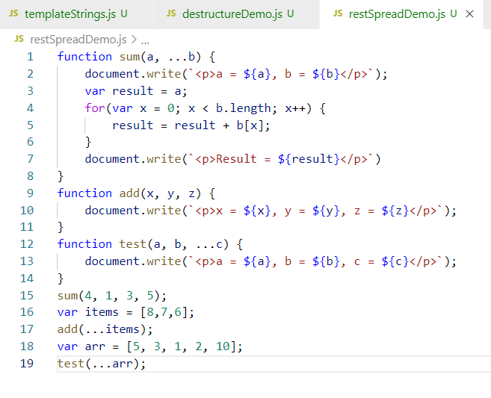

Output:

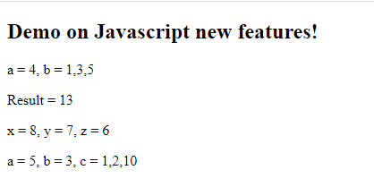

Generators

It is a special kind of function that can return multiple values one after the another on demand, return means yield as well in generators, in generators you can use yield keyword to return value & also you can use return keyword, but return must be the last execution statement, however yield can be anywhere in the function.

In generators you should call next() function to get the value from the yield, along with the value it will return done which will be true/false based on the status of generator completion, if function is completely executed then done will be true else done will be false.

Generator would yield an object with two properties when you call next(), {value, done}, value will be the data the yield returns & done will be status like true/false.

Generators are created with * beside the function or function name

i.e., function* test() or function *test()

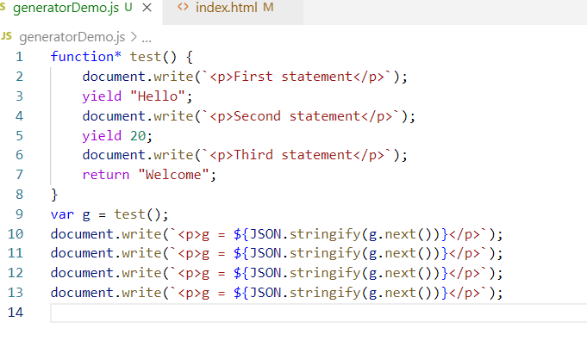

Output:

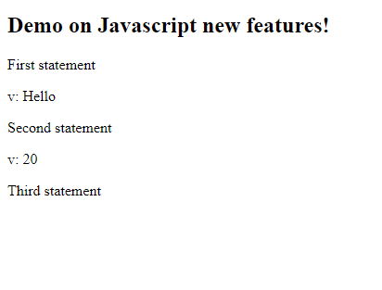

Trailing commas

It removes extra commas if you keep in the array or function parameters without giving the error.

Earlier: items = [1, 2, 3, ] was an error

Now: items = [1, 2, 3, ] is fine, because javascript trails it

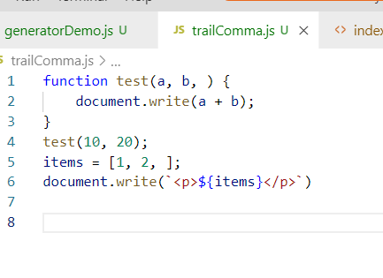

Output:

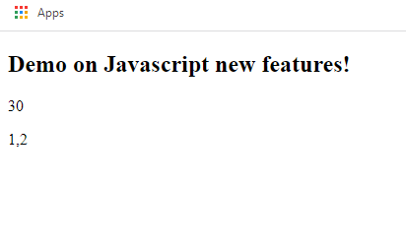

Trailing commas was a much needed feature, because most of the times developers tend to keep the extra comma because of some silly mistake either in React.js or Angular or Javascript, but now it will be removed if its extra

ex: In React.js if you create array of objects you may by mistake have extra comma as below

emp = [{name:”Alex”},{name:”Bruce”},]

ex: In Angular in the decorators you may have extra by some silly mistake

@NgModule({  
 providers : [..],   
})

Exponential Operator

It is used to write an arithmetic expression to find the powers in a simple way without using Math.pow()

Earlier: Math.pow(2, 3) returns 8

Now: 2 ** 3 returns 8

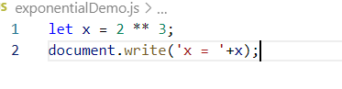

Output:

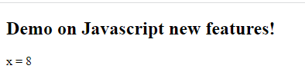

Event Handling in Javascript

It is not part of ES6 it was there since the beginning, inorder to handle the users action we handle the events, these are generated by HTML elements

HTML elements generate variety of events like

onclick, onblur, oninput, onsubmit, onmouseover, onmouseout, onsubmit and so on.

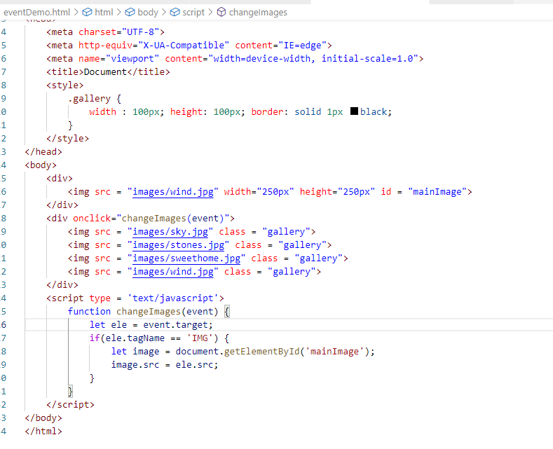

Here whenever you click on any image that is inside the div an event from that image is handled and its location is assigned to another image whose id is mainImage so that you can change the images dynamically.



Another useful feature of Javascript is form handling and validation

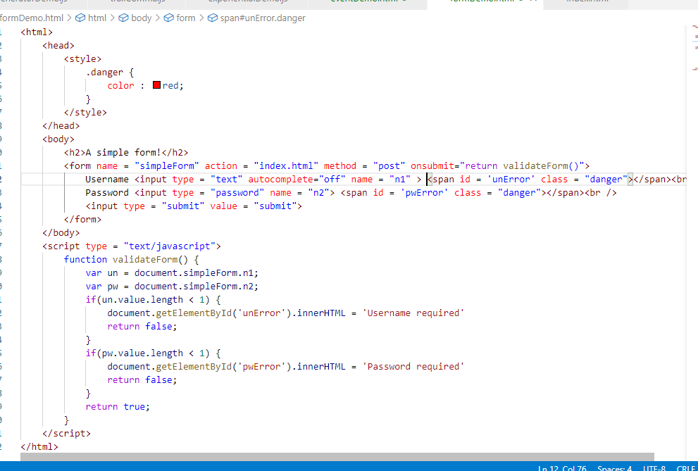

Output:

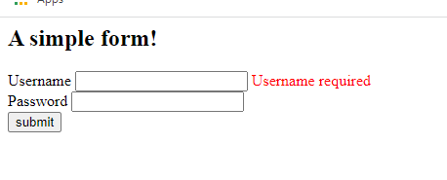

Activity

Create a form which will have 4 input elements

1. Firstname
2. Lastname
3. Password
4. Confirm Password

Validate each input so that firstname and lastname must have minimum 2 characters, whereas password & confirm password must have minimum 5 characters & their values must be same then only form must be submitted

Day 3 Agenda

* Object.entries() & Object.values()
* Static members
* Array.includes()
* padStart() & padEnd() functions
* Optional Chaining
* React.js

Object.entries() & Object.values()

These are new functionalities used to retrieve object properties & their values separately

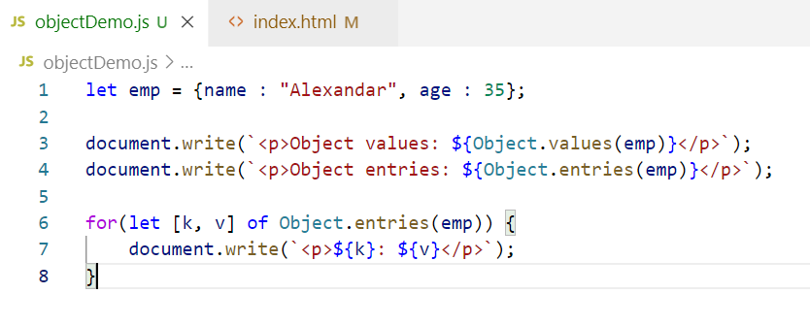

Output:

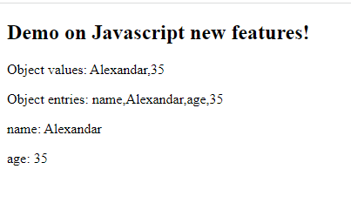

Array includes:

Earlier developers need to use index position to find the element of the array, but now you have includes() function to find the element of the array

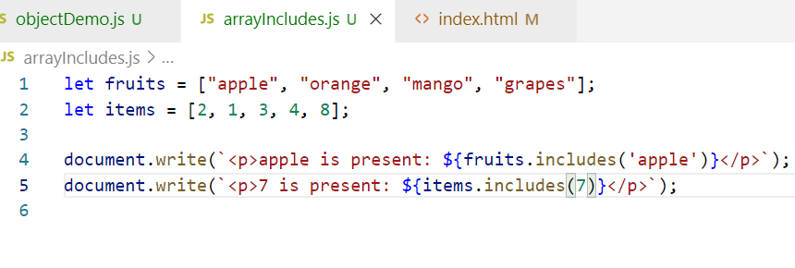

Output:

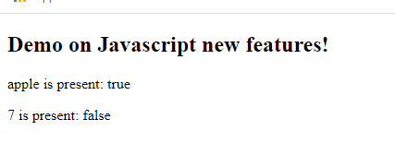

Static members:

It is used mainly to directly access the members with the class name, it is mainly used when you want fixed configuration for all the objects or to create utility functions like cloning objects and all.

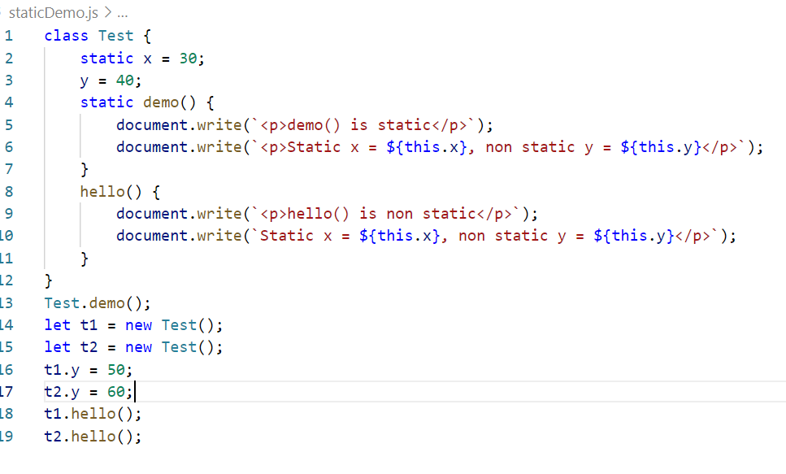

Output:

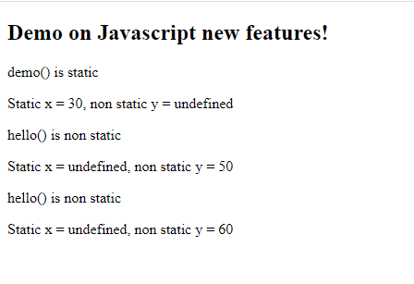

New functions for String: padStart() & padEnd()

padStart(): It adds some string in the beginning of the string until the length of the padded string matches

ex: “9809”.padStart(6, ‘0’), here the 1st argument 6 is the length of the string and 2nd argument 0 is the string that should be added in the beginning of the “9809” if the length is less than 1st argument of padStart(), so the result would be 009809

ex: “44209”.padStart(6, ‘0’) >> 044209

ex: “887733”.padStart(6, ‘0’) >> 887733, because the current string length itself is string so no padding happens

padEnd(): It adds some string at the end of the string until the length of the padded string matches

ex: “998882”.padEnd(10, ‘x’) >> 998882xxxx

ex: “9988223344”.padEnd(10, ‘x’) >> 9988223344, as the current string length and the amount of strings to pad is same it doesn’t pad.

padStart() & padEnd() doesn’t pad the extra strings if the length of the string is greather or equal to the 1st argument

Note: You can apply padStart() & padEnd() only to the strings not to the numbers, if they are numbers you need to convert them to string first

padDemo.js

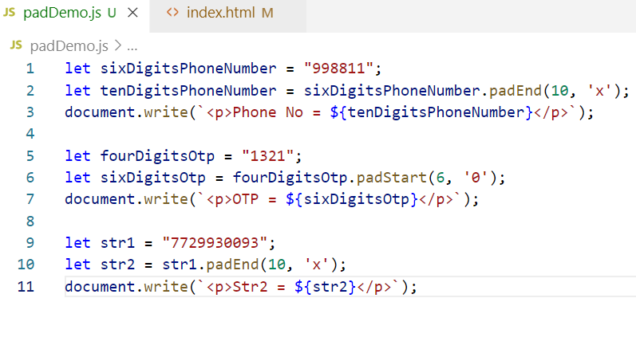

Output:

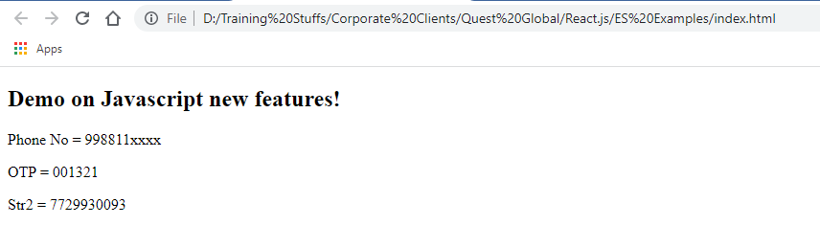

Optional Chaining(?.)

It is used to safely access the nested properties of an object to avoid errors in the javascript if in case the nested properties are not present.

Whenever there is an object with lot of intermediate properties developers tend to get errors when they access some properties which are missing in some objects to avoid that developers used to write lot of conditions to check for its existence

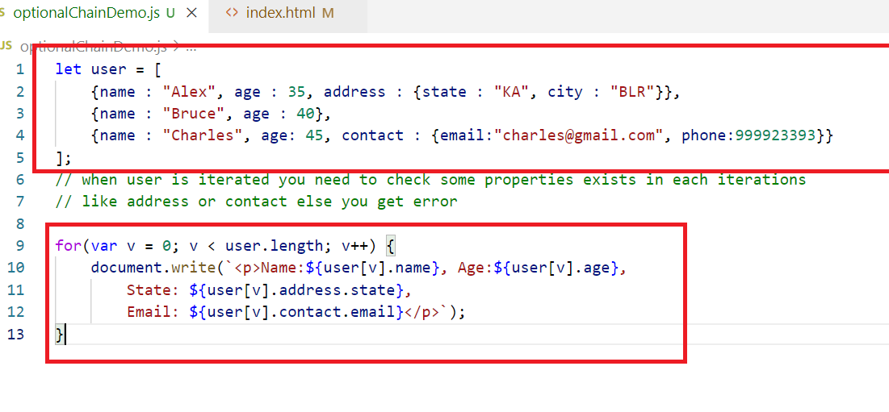

The above code gives error when iterating the item because each object iterating doesn’t have address or contact which are intermediate properties, they will be undefined & accessing their nested properties would raise the error as below:

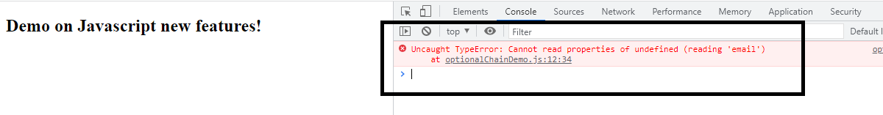

On the first iteration itself the object contact is undefined & accessing email on undefined raises error.

To avoid that you need to write lot of conditions to check undefined & then access

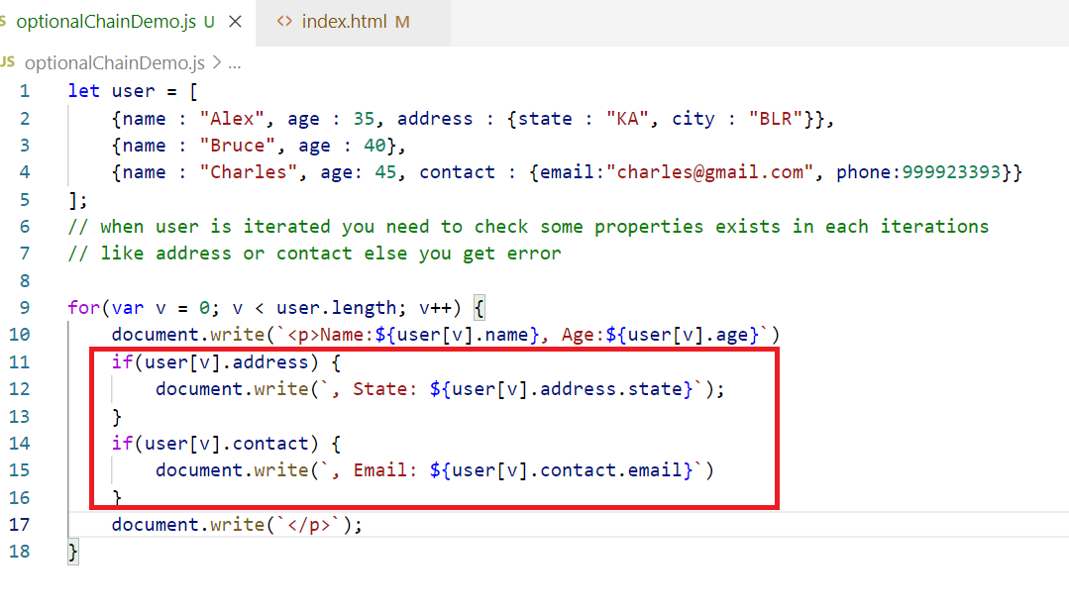

Output:

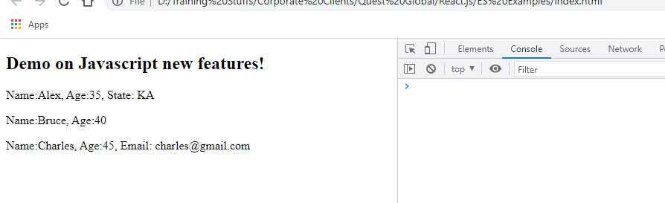

The above code may not throw error, but your application logic will be big to only check for undefined in the object, however from ES2020 onwards optional chain would allow you to safely access object properties or functions by internally checking if they exist or not using `?.`, Here `?.` means if exist then access.

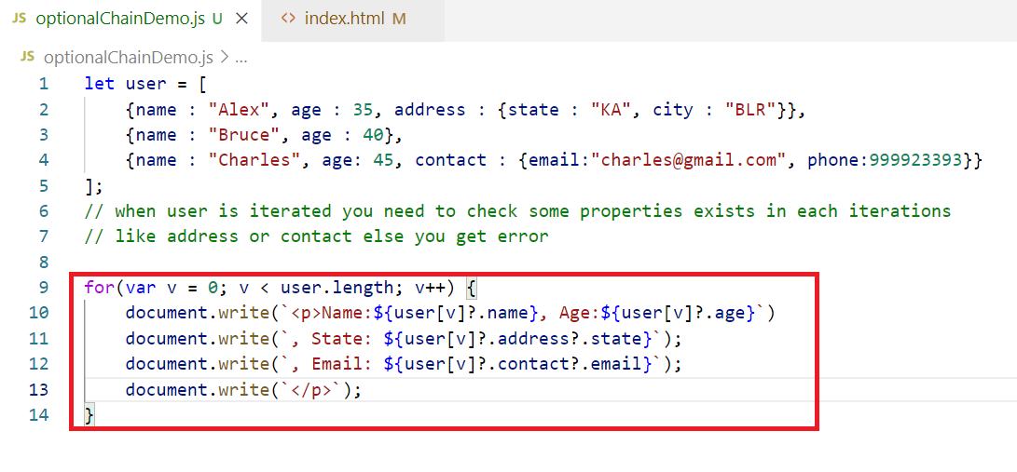

The above code stops accessing the intermediate property if it finds property doesn’t exist, i.e., if address is undefined, then it doesn’t access state from the code ‘user[v]?.address?.state’

Output  
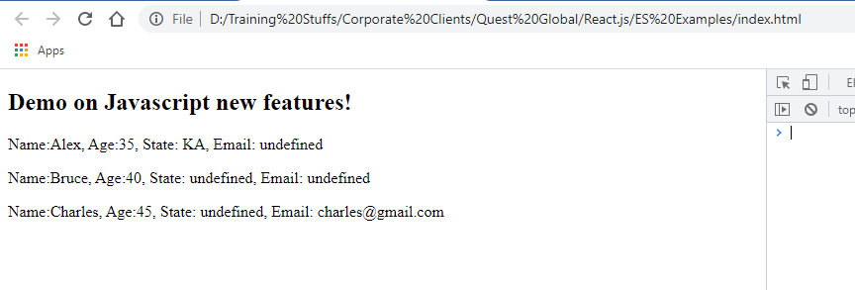

Note:

The ?. immediately stops the evaluation as soon as the property is not present which is like short-circuit, so if there are any further calls or side effects then they don’t occur.

You can also use the ?. on the functions

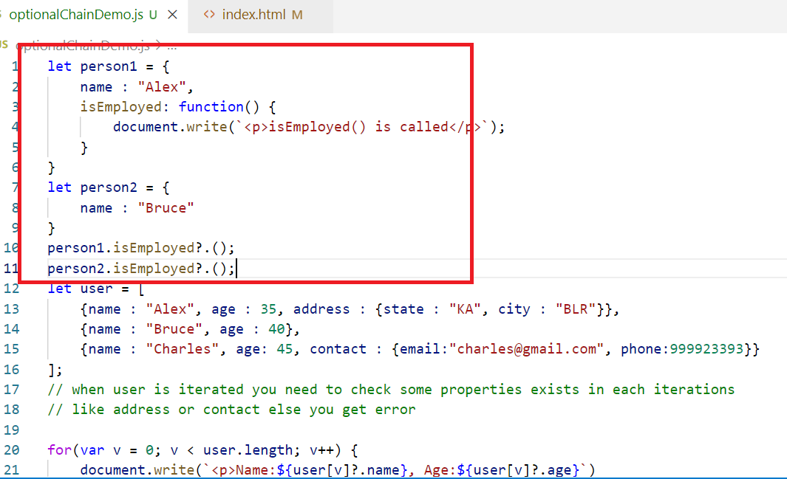

Output:

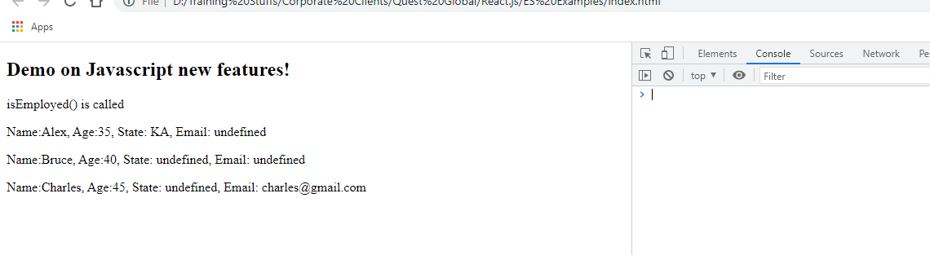

Summary:

* Keywords like let, const, class, super, extends
* Arrow function
* Template String literals
* Rest & Spread operators
* Generators
* Object & Array Destructuring
* Default values to the parameters
* Trailing commas
* Exponential operator
* padStart & padEnd
* Array.includes()
* Object.entries() & Object.values()
* Static

Activity

1. Try all the above examples
2. Using padStart() & padEnd() try the following requirements
   1. If the phone number is 10 digits split that to 6 digits and 4 digits and for the 6 digits you pad ‘x’ at the end, suppose if phone number is 9988445522, then divide it to get 998844 and add ‘x’ at the end so that result must be 998844xxxx
   2. Use Math.random() and generate an OTP of 6 digits, ensure you will add 0 at the beginning if the OTP generated is not 6 digits, suppose Math.random() returns 0.0235293 then converting it into 6 digits will give you 5 digits i.e., 23529, not 023529, hence you need to pad 0 in the beginning

React.js

It is a javascript library used to build user interfaces.

User Interfaces: The content user sees in the web page or mobile screen.

React.js allows you to develop single page applications.

Single page applications will have only one page where everything happens there, when you click on a link or a button it doesn’t reload entire page instead it refreshes only part of the page.

React.js can be used to develop web applications and mobile applications.

It uses Component based approach to develop the user interfaces.

Components: Part of the page which user sees, a web page is usually made up multiple components, you can independently develop components and use in the web page wherever required.

You can also nest the components i.e., called as child components.

Ex: In facebook, profile is the component which is reused in newsfeed, comments, like, posts and etc.

Ex: of single page applications

Twitter, facebook, gmail, angular.io, react.org, github.com.

You can develop react.js application without using any tools or softwares with CDN link from the react, however to get a better development experience we need to use some tools like:

* Node.js & NPM
* Visual Studio Code editor
* Browser

React.js uses JSX to develop the application

JSX is a superset of Javascript which makes easier to write the HTML code, because writing HTML code in Javascript is little bit complex.

But JSX is not understood by browser, hence we need a translator called Babel to convert JSX to Javascript.

Note: You write code in JSX but babel takes care of converting JSX to Javascript when you run the react code.

You need to add babel library to convert JSX to Javascript

Inorder to create components in react you need two libraries

* React
* ReactDOM

You need to add these two libraries in your script tag

Either you download the library or use CDN link.

React uses a root component to create the single page application, all the components must be inside the root component

Root component: It is created with <div> element and using react library you create react components and load all the components inside the <div>

Note: You must have only one <div> in your html file, you will only one HTML file which will be loaded in your browser & everthing happens inside this html file

You can use CDN link for react & react-dom library

index.html

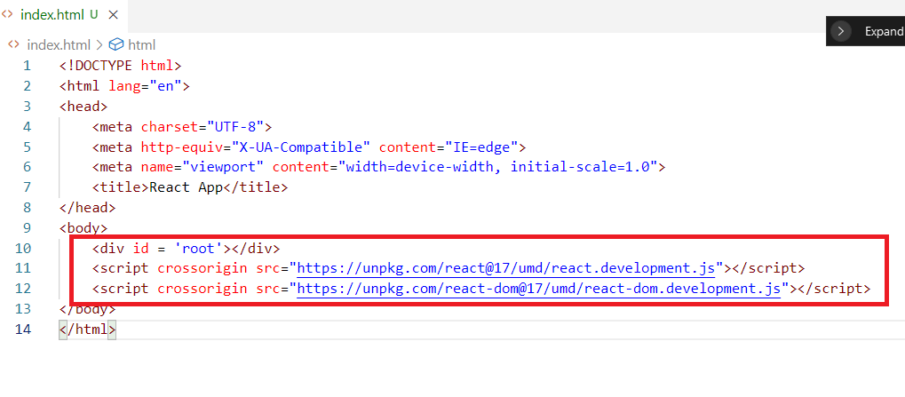

This index.html is the only file that will be loaded & the two libraries react & react-dom helps us to create components and render to the web page.

React library: It is responsible to create views/UI

ReactDOM library: It is used to render the views in the browser, it is a virtual DOM that patches the views to the real DOM.

<div id = ‘root’> it is the only node that must be present no matter how many components you create, all the components will be inside this element.

Note: You must have one root component and that must be added inside this <div> and all the other components will be inside the root component

Creating our first component using Javascript later we can use JSX

index.html

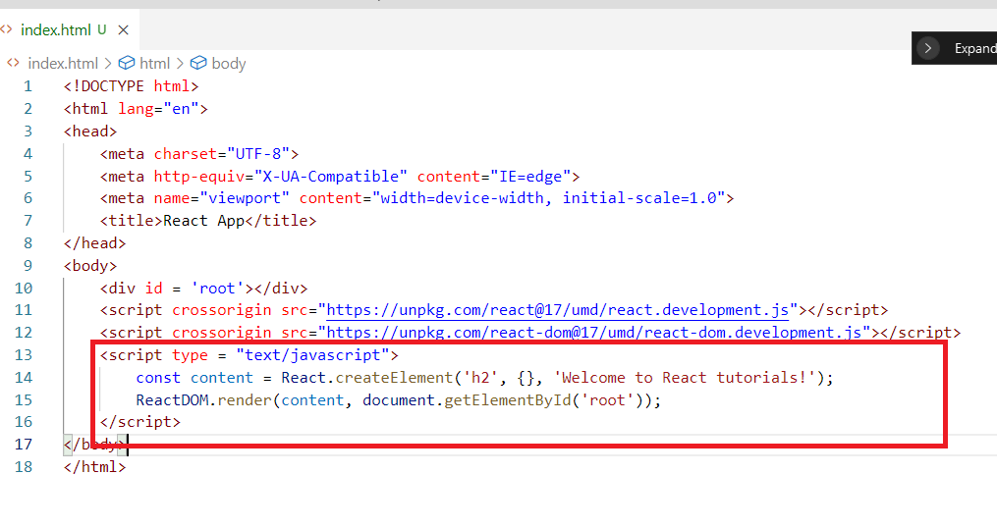

React.createElement() is a function that creates an html element mentioned in the 1st argument, along with that it will create the child node or text node which is mentioned in the 3rd argument, the 2nd argument can have styles for the element.

Styling the element created from React

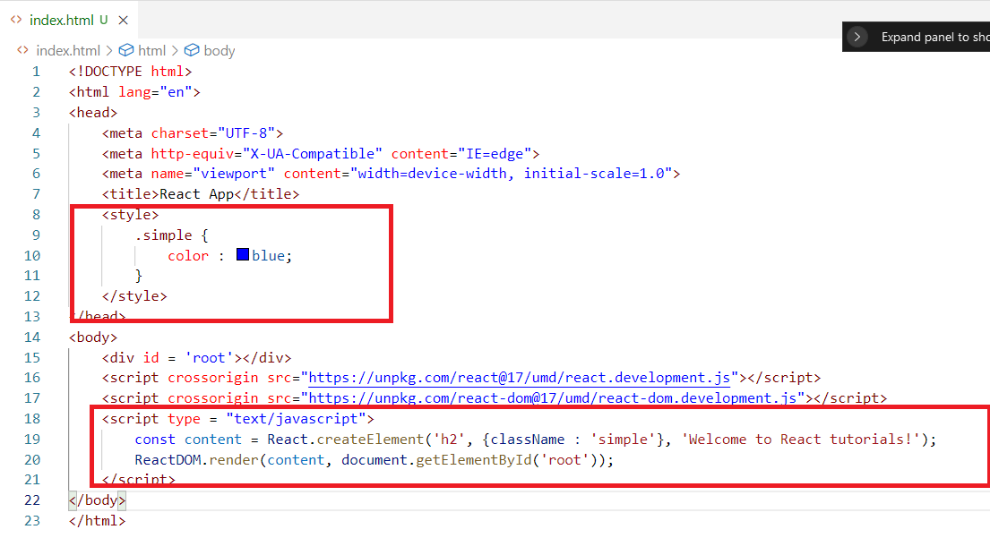

Output:

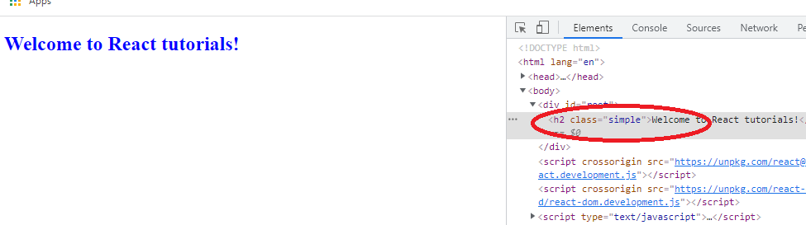

The above code written completely in Javascript (Vanilla Javascript), which will become very complex when you have lot of elements to be created.

Suppose if you want to create a list <li> of fruits

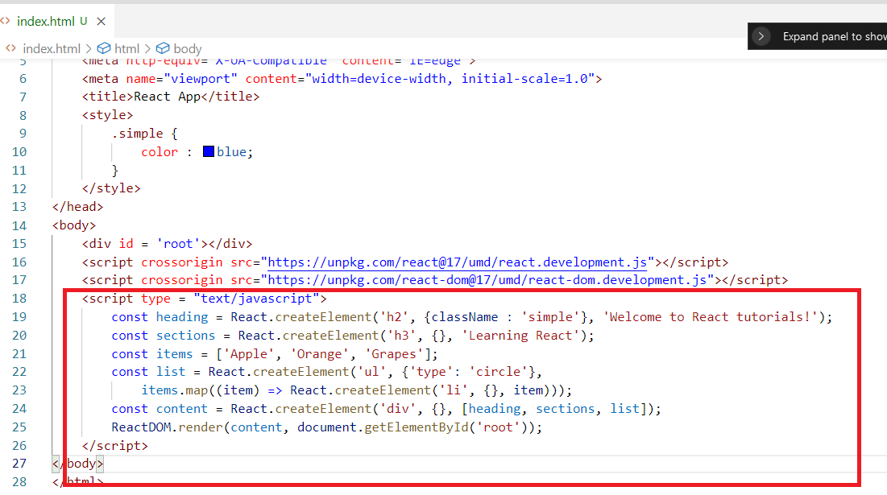

Here the list is a component which will be <ul> and inside that there must multiple <li> hence we use items.map() inside the React.createElement(ul, {}, items.map());

Output:

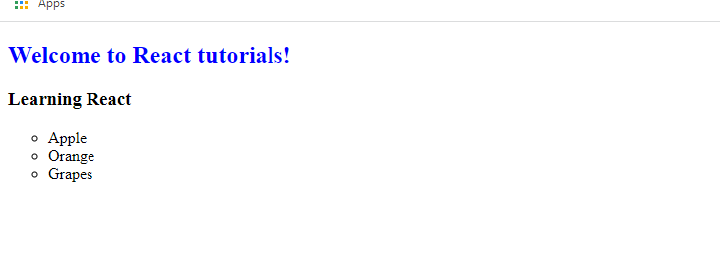

The above code looks complex because of creating HTML elements in the javascript code & also React doesn’t look simple at all if this is the case, however the code wouldn’t be complex if you use JSX.

JSX

It is a language used by React to create HTML elements in a simpler way without using React.createElements().

JSX is not understood by browser, hence we need a translator ‘babel’ who converts JSX to Javascript internally, hence you need to add babel library in your code & script type must be text/babel instead of text/javascript

Below is the CDN link of Babel

<script src="https://unpkg.com/@babel/standalone/babel.min.js"></script>

Writing HTML in JSX is very simple i.e.,

const content = (<div>Hello div element</div>)

The above code will be converted to Javascript as React.createElement(‘div’, {}, ‘Hello div element’);

Creating our first component with JSX

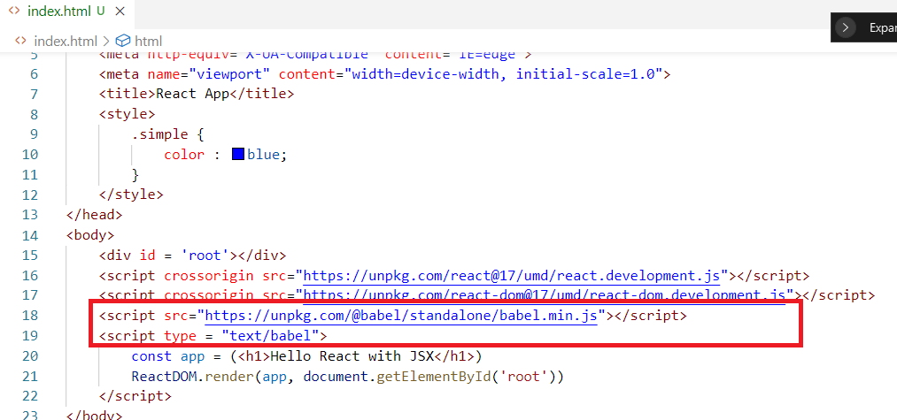

Output:

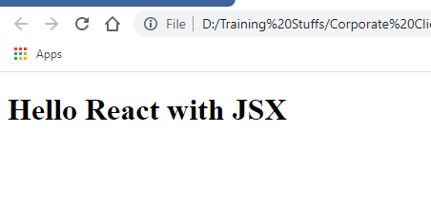

The above code has only one components, but you need to create multiple components with some name which are called as named components.

Named or Namespace components

These are the functions which will have a name & it acts like a component, but in React every named components must begin uppercase, because it will used like a tag in the HTML, hence HTML should not treat the tag as HTML tag instead it must treat it as React components.

The named components function must return the HTML element and you can use this named component inside any components.

Ex:

function Hello() {  
 return (<div><h2>Hello component</h2></div>)  
}

Now you can use <Hello /> tag inside components

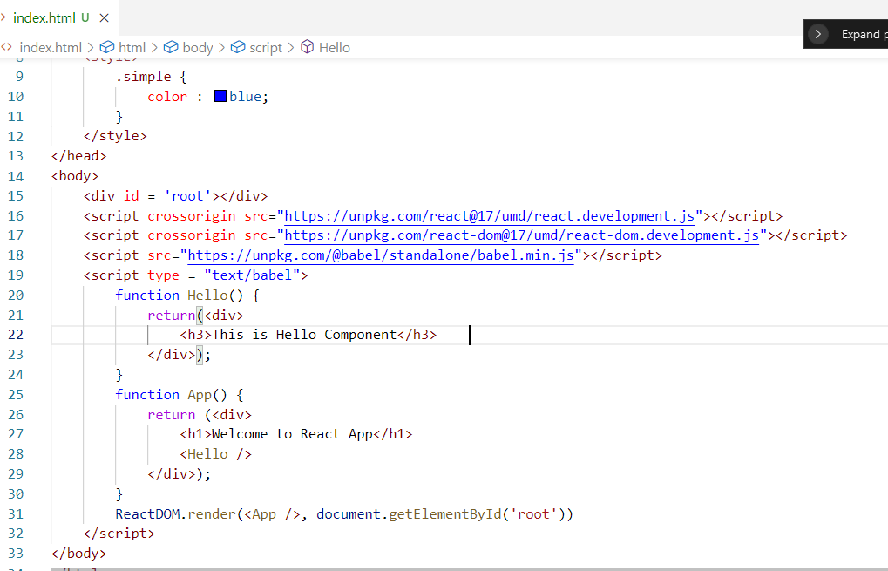

Hello & App are the two components which returns the HTML elements & App acts like a root component as it is loaded in the root node & App component as a nested Hello component.

Output:

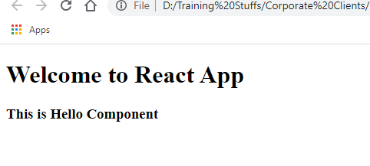

The above code is very complex to write in Javascript as it involved lot of React.createElement() & adding another element inside it would be more complex.

Javascript expressions supported in JSX

Since JSX is converted to Javascript, you can write lot of Javascript statements, but everything must be inside {}.

{}: It is used to write Javascript expressions.

Suppose you want to display the name, then you can use {name}.

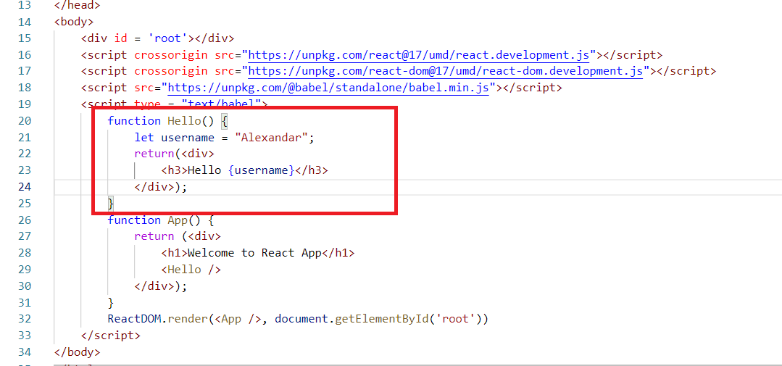

Output:



You can also call the Javascript functions from JSX

myscripts.js

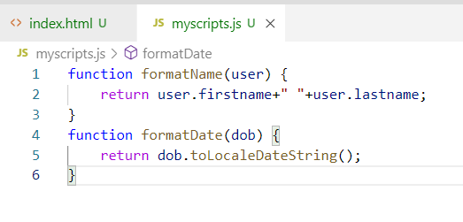

index.html

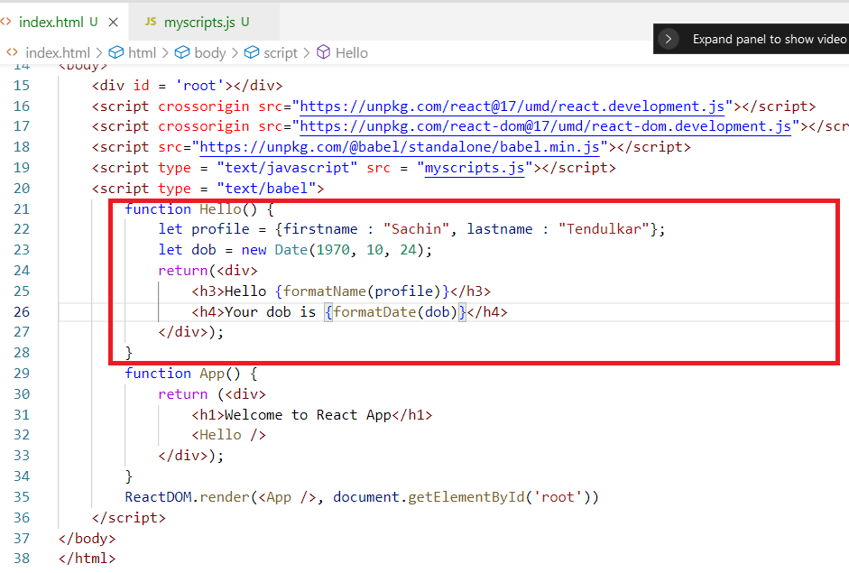

Output:

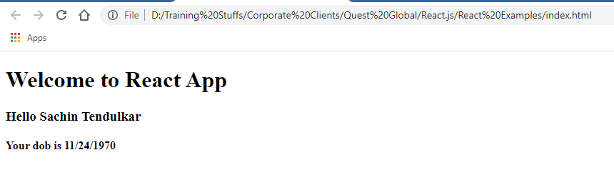

You can specify attributes with JSX

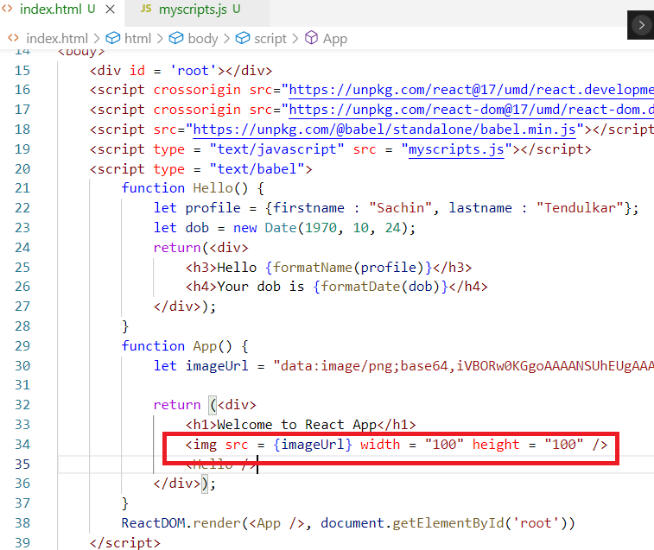

Output:

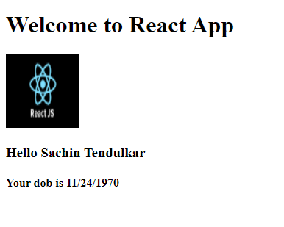

Using classes to create the components

You must extend React.Component and use render() function inside the class to create the component

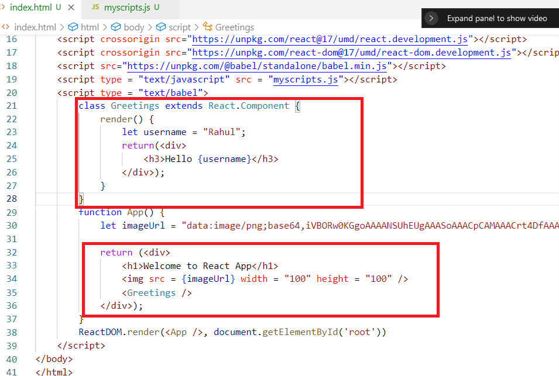

Output:

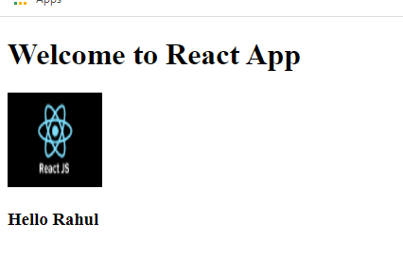

ReactDOM or Virtual DOM:

It is a virtual DOM that updates the real DOM, the react uses Virtual DOM to update the real DOM instead of updating real DOM directly to increase the performance at the front-end.

Virtual DOM compares the Real DOM and updates only the DOM that needs to updated instead of refreshing the entire DOM tree, it only updates the particular DOM element.

Usually the Javascript or any Javascript libraries that updates part of the document refreshes the entire DOM tree but for user it looks like only the particular part is updated, but in case React.js not only the part of the document will be updated but also only particular DOM element will be updated not the entire DOM tree.

Updating the part of the document through javascript

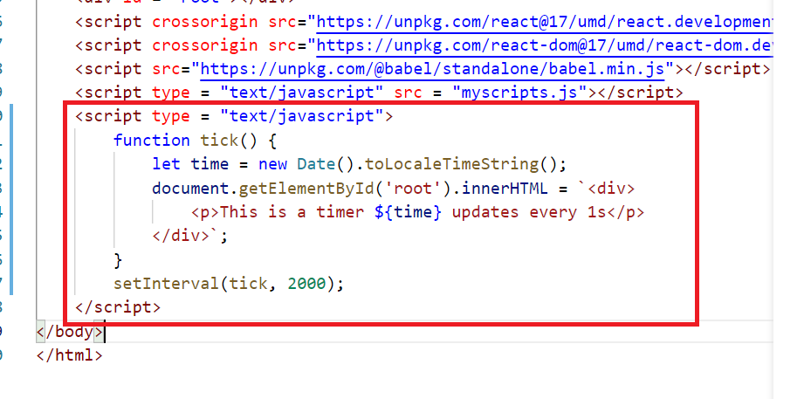

Output:

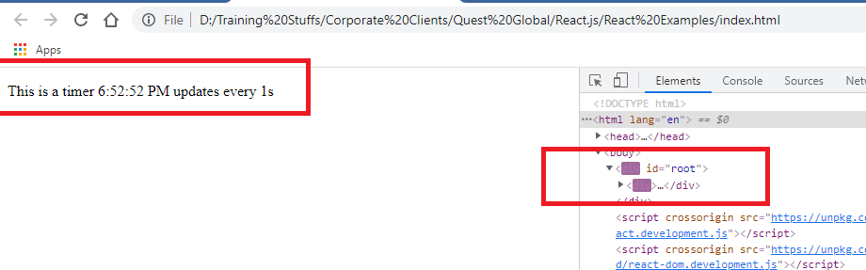

Though the user thinks that only the seconds in the time is updating without reloading the entire page, but in the DOM tree you can observe the entire tree is reloading, but user could unable to notice that because except second all other are same they are rendered as it is hence that changes we can’t detect.

Here the rendering will be more if the entire DOM is refreshed, hence the react.js uses the concept of Virtual DOM and patches the changes to the Real DOM without reloading the entire tree, instead it updates only the node that need the changes.

Same program with ReactDOM of React.js

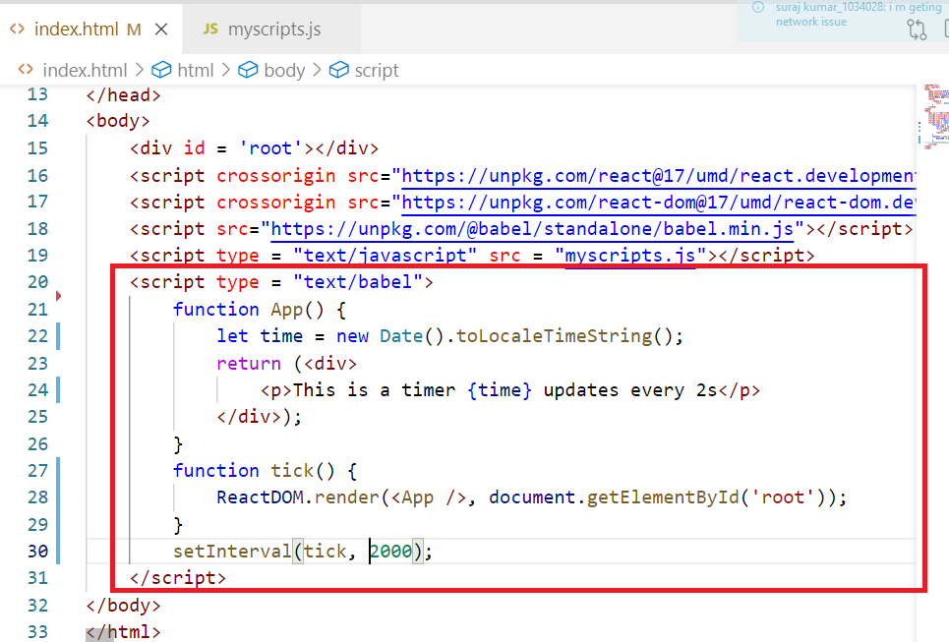

Output:

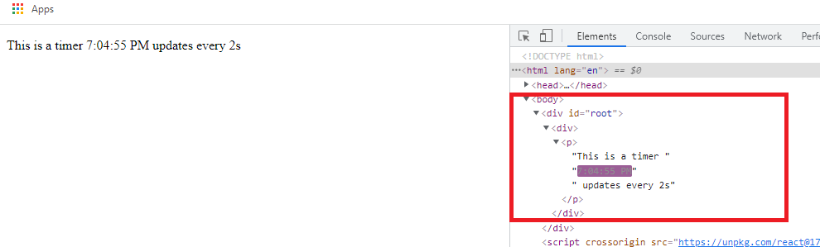

The virtual DOM only updates the changes required not the entire DOM tree.

The above approach of using index.html & loading it locally is good for learning purpose, but when you develop react applications you need to launch your application in the server and you must get lot of benefits at the time developing the code like auto-compilation, auto-reload feature, a well structured project separating javascript and html, a configuration file to have commands to run, test & build the application, hence you can use some tools like

* Webpack: A module bundler for all the Javascript technologies
* React toolkit from React community

Webpack:

A static module bundler that can bundle all the files of your javascript into a single build file which you can plug to the HTML, so that you can avoid adding each and every Javascript file into the HTML

Whenever you create React applications, you create lot of Javascript files and import these files into other files and adding these Javascript files to the HTML would be a difficult task, hence if you use webpack, it bundles all the javascript files into a single and keeps the dependency graph in track internally to avoid any runtime errors, the single file could be included in the HTML.

Benefits of using Webpack

* Bundles all the Javascript files into a single file which would helpful during the production
* Provides a development server where developers can launch their application in the development server
* Provides auto-reload feature while you modify the application without user interaction it updates the browser output
* You can provide commands in a configuration file to run the application instead of manually launching the HTML file

Note: You must have node.js installed to use webpack, because you need to download javascript libraries from npm registry

Configuring the Webpack for the Javascript application

Setting up the project with public and src folder

public: It will have HTML file

src: It will have Javascript files

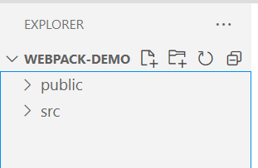

This project needs to use Webpack and you need to download the libraries from npm, hence you must use one file called package.json

package.json: It is the heart of any node project, it will have all the project information i.e., metadata, it records important metadata like project name, commands or scripts, dependencies

You don’t have to manually create package.json, you need to use a command called ‘npm init -y’ that creates package.json file automatically and it internally assumes the current directory as the project name, in our case webpack-demo is the current directory that itself is chosen as project directory.

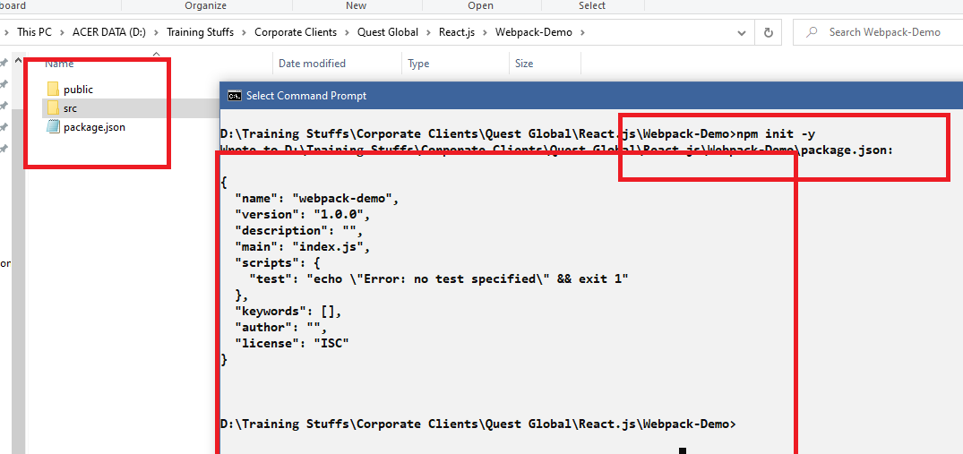

Create an html file index.html inside the public folder

public/index.html

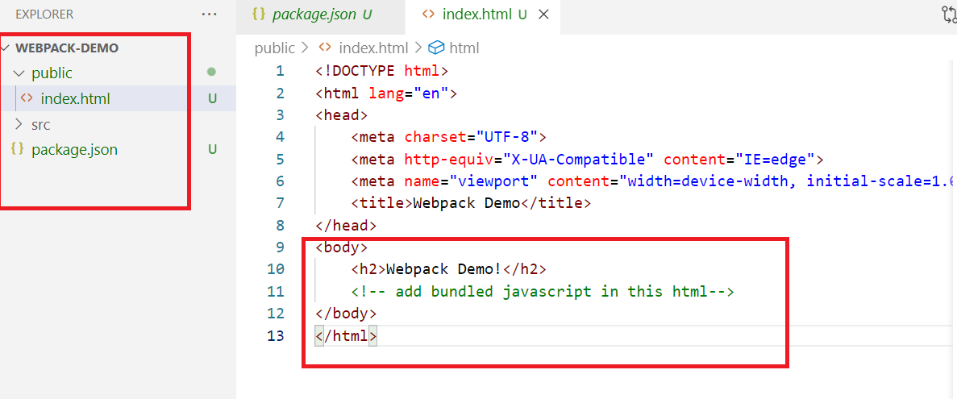

The above project still doesn’t have webpack library we need to install 3 libraries

* webpack
* webpack-cli
* webpack-dev-server

All the above 3 libraries can be installed using npm command, these libraries will be recorded in package.json, and the libraries will be downloaded in node_modules folder.

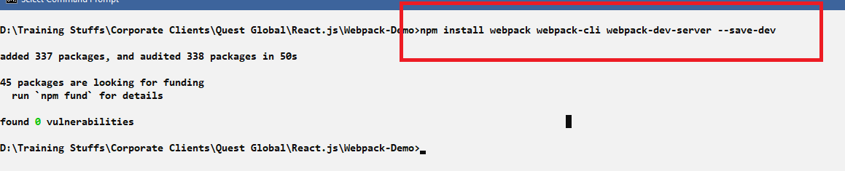

You can notice these 3 libraries recorded in package.json

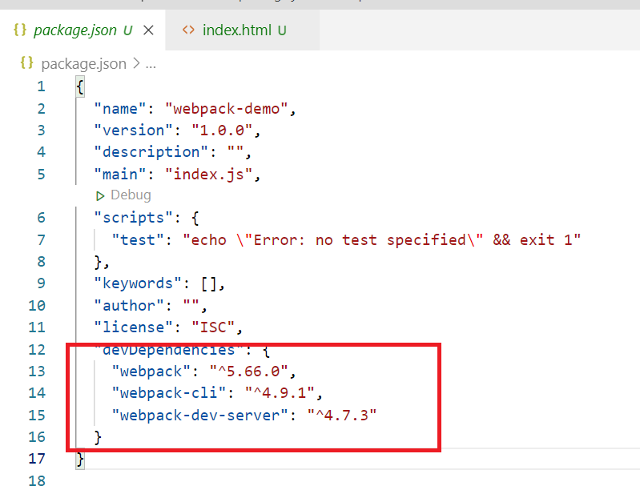

You can also notice package-lock.json file along with the package.json, it is an auto-generated file, which will have the complete tree of npm downloads.

What are these libraries do

webpack: it bundles all the javascript files into single file & build our application

webpack-dev-server: it is a development server to launch your application during the development, it gives many features like auto-reload and opening the application in some port and son on.

webpack-cli: it provides some useful commands for developers to increase the speed of the development process

Create a Javascript file with some welcome message

src/index.js

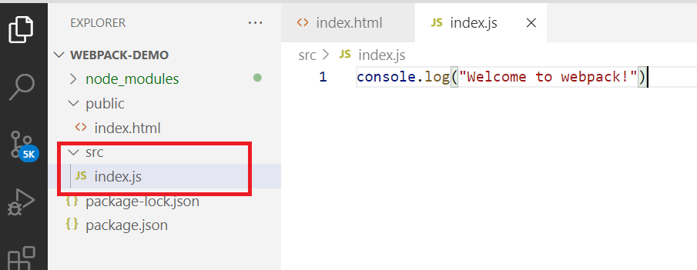

Webpack configuration file

This is the file that will mention the path of HTML files and Javascript files and also the output of the bundled file that bundles all the javascript file, so that with a single command your application will be launched by looking at this configuration file.

Create the webpack.config.js file in the project directory

webpack.config.js

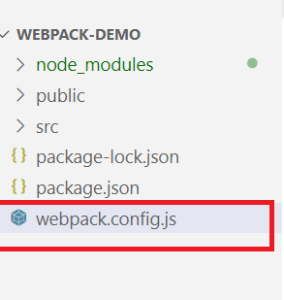

Add the entry point file index.js & public folder as the path to the entry point to launch the HTML and a single file that will bundle all the javascript files

webpack.config.js

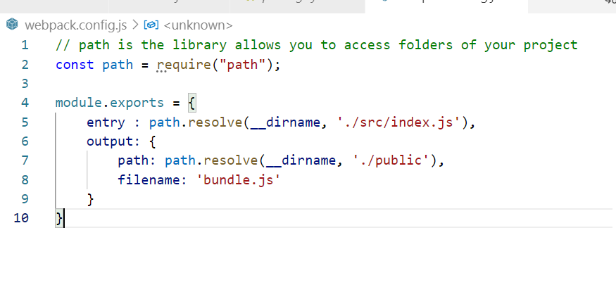

The output ./public will look for index.html file to launch, the index.html must have bundle.js file indluded

Lastly you need to enter a command to search this webpack.config file, hence in package.json you will write a script called ‘start’ that should search webpack.config.js file and launches the application in development server.

package.json

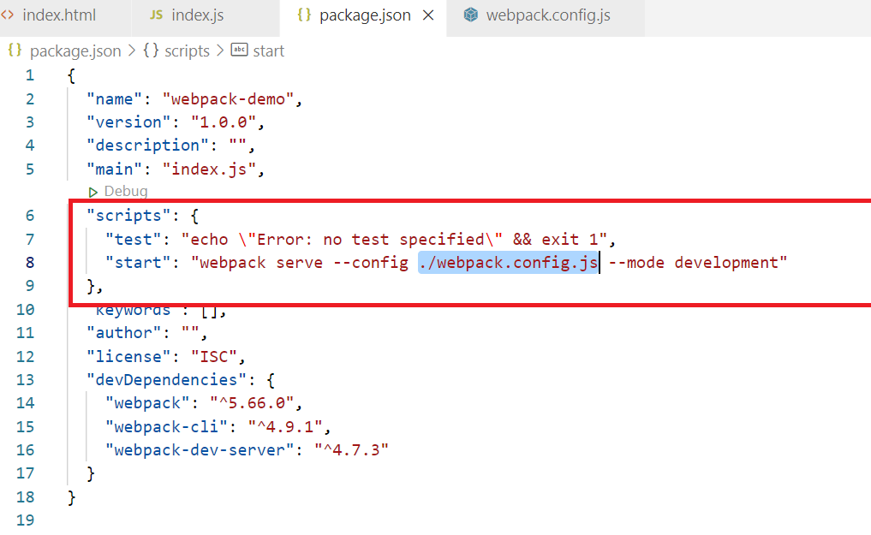

Since webpack.config.js bundles all the scripts inside bundle.js we need to add only bundle.js in the index.html,

public/index.html

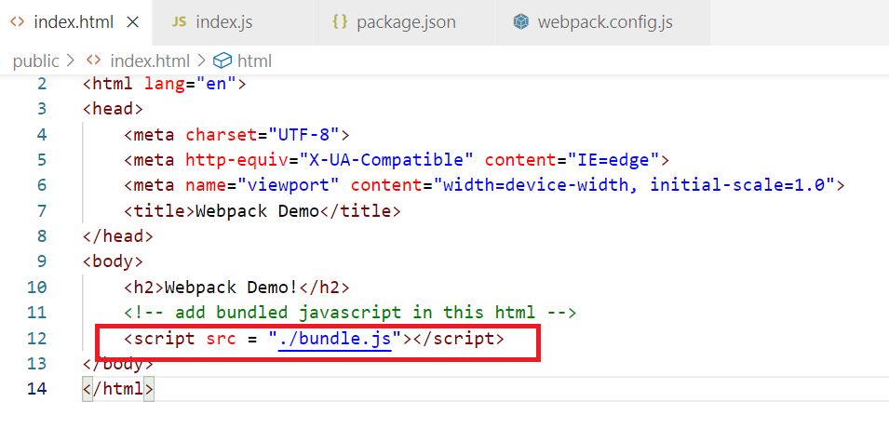

Now you can use npm start command that runs webpack serve script by looking webpack.config.js file

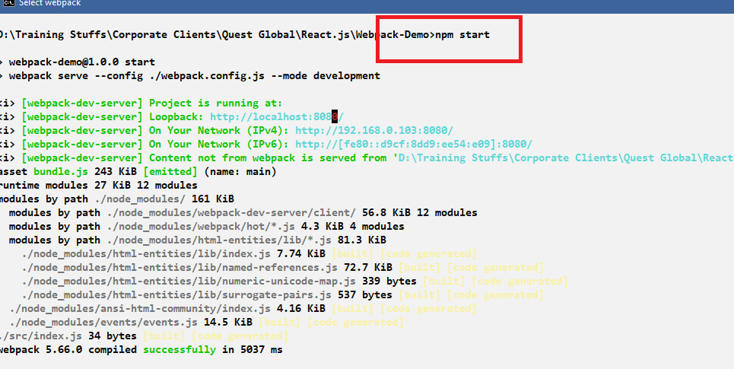

Output:

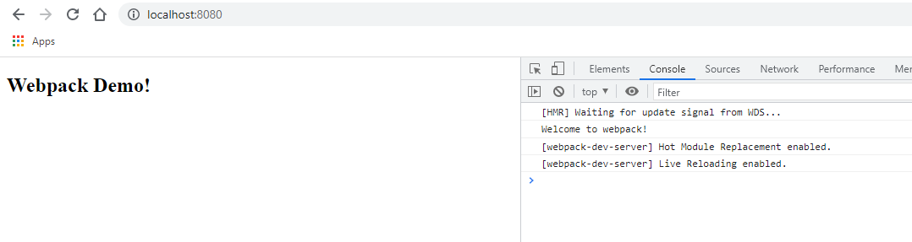

Now the index.html is automatically loaded because of webpack and also if you make any changes in the application it will be reflected in the browser.